A Look at the chip:
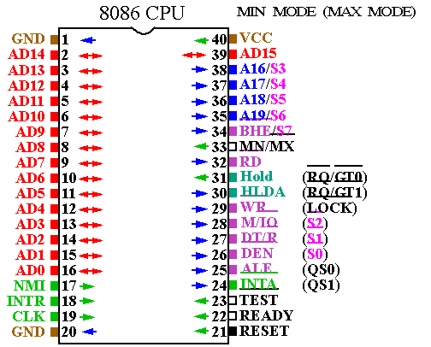

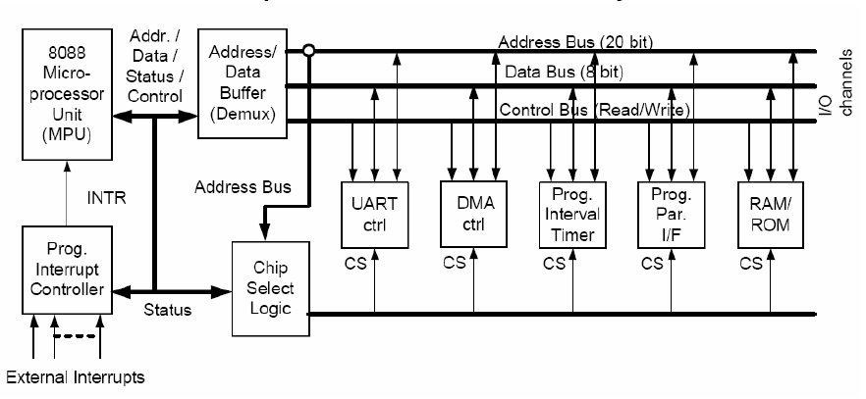
Analogy:
EU – Thinking Ability of Human Brain
BIU – Communication Ability of Human Brain
Registers – Memorizing Ability of Human Brain
Flag Register – Realizing Something Happened
Memory – Books
BUS – Neural
I/O Devices – Mouth, Eyes, Nose, Hands …
Interrupts – Compulsory Commands That Disturbs You
…
The 20-bit Physical Address is formed with 16-bit registers:

[Seg. Reg.] * 10H |  | [Addressing Mode]
[DS] | *10H + | Const. Displacement | + | BX | + | SI  DI
[SS] | *10H + | Const. Displacement | + | BP | + | SI  DI
There are a total of 17 different legal memory addressing modes on the 8086: disp, [bx], [bp], [si], [di], disp[bx], disp[bp], disp[si], disp[di], [bx][si], [bx][di], [bp][si], [bp][di], disp[bx][si], disp [bx][di], disp[bp][si], and disp[bp][di].

Choice of Seg. Reg. is IMPLICIT
CS for IP, to indicate instruction position
DS & SS for Memory Addressing Modes (Data & Stack)
ES used in special instructions, also to access the memory

MOVS - Move String (Byte or Word)
MOVSB // MOVSW
Copies data from addressed by DS:SI (even if operands are given) to the location ES:DI destination and updates SI and DI based on the size of the operand or instruction used. SI and DI are incremented when the Direction Flag is cleared and decremented when the Direction Flag is Set. Use with REP prefixes.
Excerpted from http://spike.scu.edu.au/~barry/80x86_inst.html

A better tool than TASM : Visual Microprocessor Emulator
Found at: http://www.emu8086.com/
- Integrated Editing Environment & Assembler
- Monitor All the Registers in the Processor
- Trace the Execution of Your Program
- See the Change of Flag Bits in the Status Register
- Monitor the Memory – Test All the Addressing Modes
- Try All the Instructions at ease
Flags
Most Arithmetic and Logic Instructions affect the processor status register (or Flags)
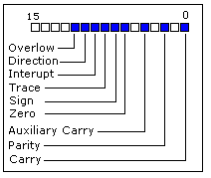
As you may see there are 16 bits in this register, each bit is called a flag and can take a value of 1 or 0.
- Carry Flag (CF) - this flag is set to 1 when there is an unsigned overflow. For example when you add bytes 255 + 1 (result is not in range 0...255). When there is no overflow this flag is set to 0.
- Zero Flag (ZF) - set to 1 when result is zero. For none zero result this flag is set to 0.
- Sign Flag (SF) - set to 1 when result is negative. When result is positive it is set to 0. Actually this flag take the value of the most significant bit.
- Overflow Flag (OF) - set to 1 when there is a signed overflow. For example, when you add bytes 100 + 50 (result is not in range -128...127).
- Parity Flag (PF) - this flag is set to 1 when there is even number of one bits in result, and to 0 when there is odd number of one bits. Even if result is a word only 8 low bits are analyzed!
- Auxiliary Flag (AF) - set to 1 when there is an unsigned overflow for low nibble (4 bits).
- Interrupt enable Flag (IF) - when this flag is set to 1 CPU reacts to interrupts from external devices.
- Direction Flag (DF) - this flag is used by some instructions to process data chains, when this flag is set to 0 - the processing is done forward, when this flag is set to 1 the processing is done backward.
Excerpted from http://www.ziplib.com/emu8086help/asm_tutorial_06.html
Flags for conditional jump
JE => Jump if Equal ZF=1
JG => Jump if Greater (signed) ZF=0 and SF=OF
JGE => Jump if Greater or Equal (signed) SF=OF

JA,JAE,JB,JBE,JC,JCXZ,JE,JG,JGE,JL,JLE,JNA,JNAE,JNB,JNBE,JNC,JNE,JNG,JNGE,JNL,JNLE,JNO,JNP,JNS,JNZ,JO,JP,JPE,JPO,JS,JZ

STOS - Store String (Byte, Word)
Stores value in accumulator to location at ES:DI (even if operand is given). DI is incremented/decremented based on the size of the operand (or instruction format) and the state of the Direction Flag.

