~~~~~~~~~~~~~~~~~~~~~~~~~~~~~~~~~~~~~~~~~~~~~~~~~~~~~~~~~
LEA (Load Effective Address):
lea reg16 , memory
This instruction loads the 16 bit register with the offset of the location specified by the memory operand.
LEA ax,1000h[bx][si],for example, would load ax with the address of the memory location pointed at by 1000h[bx][si]. This, of course, is the value 1000h+bx+si.
Lea is also quite useful for obtaining the address of a variable. If you have a variable MYVAR somewhere in memory, lea bx,MYVAR will load the bx register with the address (offset) of MYVAR.
~~~~~~~~~~~~~~~~~~~~~~~~~~~~~~~~~~~~~~~~~~~~~~~~~~~~~~~~~
IN Input (read) from port
Syntax: IN AL, op8
IN AX, op8
op8: 8-bit immediate or DX
Action: If destination is AL, read byte from 8-bit port op8.
If destination is AX, read word from 16-bit port op8.
~~~~~~~~~~~~~~~~~~~~~~~~~~~~~~~~~~~~~~~~~~~~~~~~~~~~~~~~~
OUT Output (write) to port
Syntax: OUT op, AL
OUT op, AX
op: 8-bit immediate or DX
Action: If source is AL, write byte in AL to 8-bit port op.
If source is AX, write word in AX to 16-bit port op.
~~~~~~~~~~~~~~~~~~~~~~~~~~~~~~~~~~~~~~~~~~~~~~~~~~~~~~~~~
INT 21H,9 - Print String
AH = 09
DS:DX = pointer to string ending in "$"
returns nothing
- outputs character string to STDOUT up to "$"
- backspace is treated as non-destructive
- if Ctrl-Break is detected, INT 23 is executed

REP - Repeat String Operation
Usage: REP
Modifies flags: None
Repeats execution of string instructions while CX != 0. After each string operation, CX is decremented and the Zero Flag is tested. The combination of a repeat prefix and a segment override on CPU's before the 386 may result in errors if an interrupt occurs before CX=0.

To change to a new line, you should output two chars in sequence.
They are 0x0D ("Carriage Return") and 0x0A ("Line Feed").
'$' is the end of a string for INT 21H,9
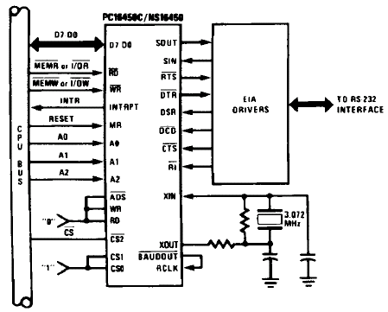
HTTP://ee2007.cjb.net
The seg operator does two things. First, it extracts the segment portion of the specified address, second, it converts the type of the specified expression from address to constant. An instruction of the form mov ax, seg symbol always loads the accumulator with the constant corresponding to the segment portion of the address of symbol. If the symbol is the name of a segment, MASM will automatically substitute the paragraph address of the segment for the name. However, it is perfectly legal to use the seg operator as well. The following two statements are identical if dseg is the name of a segment:
mov ax, dseg
mov ax, seg dseg
Offset works like seg, except it returns the offset portion of the specified expression rather than the segment portion. If VAR1 is a word variable, mov ax, VAR1 will always load the two bytes at the address specified by VAR1 into the ax register. The mov ax, offset VAR1 instruction, on the other hand, loads the offset (address) of VAR1 into the ax register. Note that you can use the lea instruction or the mov instruction with the offset operator to load the address of a scalar variable into a 16 bit register. The following two instructions both load bx with the address of variable J:
mov bx, offset J
lea bx, J

