Memory (I/O) address assignment
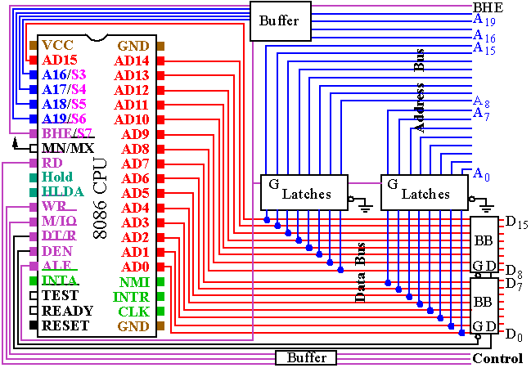
Each memory chip covers a section of memory address
By analyzing the addresses for a single chip, we find:
- Several most significant bits are in common.
- Several least significant bits various from zeros to ones.
  - Example: 4K * 8-bit chip starting at 10000h
From 10000h to 10FFF
0001 0000 0000 0000 0000
0001 0000 1111 1111 1111
  - What if we have a chip containing 4000 bytes?
Then, no such easy break up...
We prefer memory chip sizes like 256,512,1024…
- The higher part is for CS logic, while the lower part is connected to the chip directly.
Difference between 8088 and 8086
A1
A1
- What is the supported memory size of 8088? And 8086?
- 8086 is fully compatible with 8088.
  - All programs for 8088 must work for 8086.
  - Byte-based memory accesses are the same.
  - Word-based memory accesses are partially optimized.
    - Word alignment matters. See the example:
A word at address A0000h and A0001h
…0000 …0001
…0001 …0010
    - Only even-addressed words will be loaded in one cycle in 8086 processors.
- Data Bus Interface for 8086
  - Even addressed bytes are accessed on D7~D0
  - Odd addressed bytes are accessed on D15~D8
  - Thus, even addressed words is easily on D15~D0
    - A19~A1 represents the word
    - A19~A1 will be sent to both even and odd banks.
  - However, odd-addressed words can not be accessed in one cycle
    - Because the even and odd banks needs different values for A19~A1
    - Such accesses will be two byte-operations.
- How to support this structure?
A0 = 0 | Byte | Even
A0 = 0 | Word | Even & Odd
A0 = 1 | Byte | Odd
A0 = 1 | Word | None
  - A0 decides the even bank
  - What for the odd bank? We have /BHE!!!
BHE* | A0 | CS*
0 | 0 | Choose both odd and even memory bank
0 | 1 | Choose only odd memory bank
1 | 0 | Choose only even memory bank
1 | 1 | None is chosen

